**ASSIGNMENT 3 - UNIVERSITY MODEL WITH ENHANCEMENTS TO INCLUDE PERFORMANCE DATA**

**Team Members:**

Mohit Daswani - 002102079

Nagashree Seshadri - 001050979

Sujaykumaran Palanikumar Sankarapandian - 002108932

Objective:

To Design a Feedback loop involves tracking Student Alumni in Industry positions over a period of 5 years with regard to the usefulness of the College Curriculum Course Work from their time at the University. This mechanism in-turn helps the University assess the performance and efficacy of the Course Offerings.

Analysis of the Problem Statement:

Universities need to ensure that their students are learning in accordance with the Industry Demands to a large extent. However, it may seem that a significant gap exists between the coursework provided at College versus what is implemented at the Industry. In order to bridge the gap, a solution is proposed which involves tracking students over a 5 year period and looking at the Course Offerings which they found useful for their Professional Success and incorporating changes to the Course Offerings to the university level accordingly.

Performance Evaluation :

University Performance Evaluation begins by taking major performance parameters into account. The parameters involved are based on different types of evaluations used for the student. Since the dynamic component is the student and can be assigned a metric over a period of 5 years as they move across different phases from being a student to an employee - the metric changes from GPA, Course Impact over a period of time to Employee rating.

We propose a solution where - the University’s performance is a weighted combination of these numeric parameters.

In our model, we consider -

1. Employee rating and performance is assigned by the Employer out of 10 and is considered for 50% of the University Performance aggregate.
2. Student GPA which is assigned for the entire of the student’s duration in the University. The GPA is generally calculated out of 4.0. The University Performance derives - 25% of its weightage from it.
3. Course Impact - is rated by the usefulness of the courses taken by the student as a part of their coursework. The course impact score is scored out of 100. The University Performance derives 25% of its total weight from it.

Hence University Performance Metric = **0.5 * Employee Rating / Performance of Student (x / 10) + 0.25 * GPA(y/4.0) + 0.25 * Course Impact (z/100).**

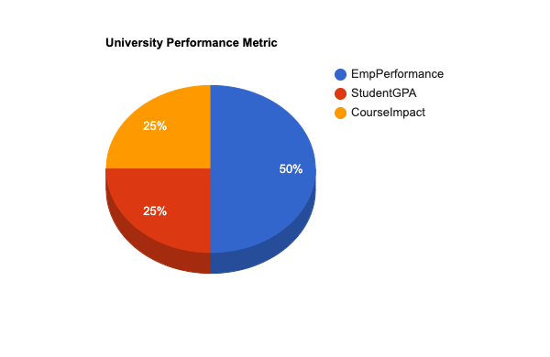

Multiple Cases arising from the Data Aggregation System:

Parameters Considered - let A be a Course Impact parameter - Needs Improvement (<50) or High (>50).

B - Student’s Professional Performance - Needs Improvement (< 7.5) or High.(> 7.5)

C - Student GPA - needs improvement (< 3.2) and good ( > 3.2).

| **Course Impact** | **Student Professional Performance** | **Student GPA** | **Observations.** |
| --- | --- | --- | --- |
| < 50 | < 7.5 | < 3.2 | Student needs improvement in Professional Performance, GPA and no course impact was noticed. No correlation between University Performance and parameters |
| < 50 | < 7.5 | > 3.2 | Student has a good GPA, but a below average Professional Performance, no course impact was noticed. No strong correlation between University Performance and parameters. |
| < 50 | > 7.5 | < 3.2 | Student has good Professional Performance, but needed improvements in GPA. No course impact was noticed . No strong correlation between University Performance and Employee Performance. |
| < 50 | > 7.5 | > 3.2 | Student has a good GPA, good Professional Performance, however, no course impact was noticed. There is a remarkable correlation between University Performance and Employee Performance. |
| > 50 | < 7.5 | < 3.2 | There was a good course Impact, student needs improvement in both GPA and Employee Performance. There is no significant correlation between Employee performance and University Performance. |
| > 50 | < 7.5 | > 3.2 | Student needs an improvement in Employee Performance, an improvement is needed in GPA, good course impact was also noticed. There is a correlation between parameters and University Performance. |
| > 50 | > 7.5 | < 3.2 | Student has a good Employee Performance, an improvement is needed in GPA, good course impact was also noticed. University Performance for this student has been significant. |
| > 50 | > 7.5 | > 3.2 | Student has a good GPA, good Employee Performance, good course impact was also noticed. University Performance for this student has been remarkable. |

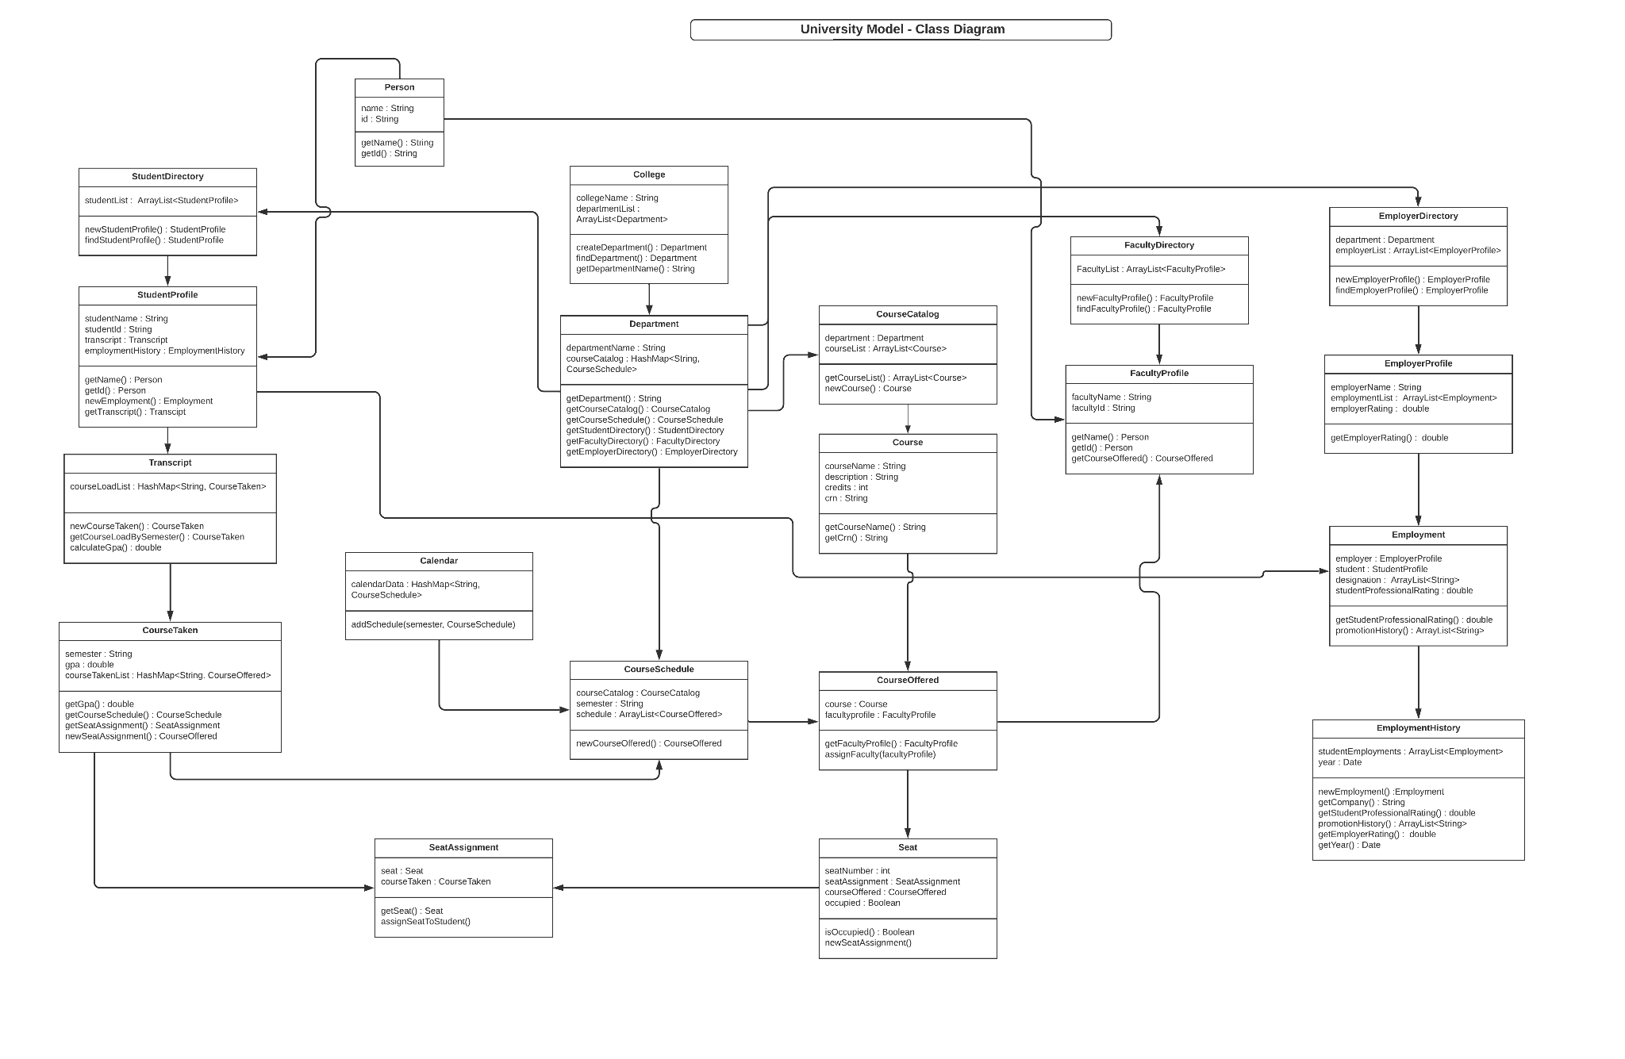

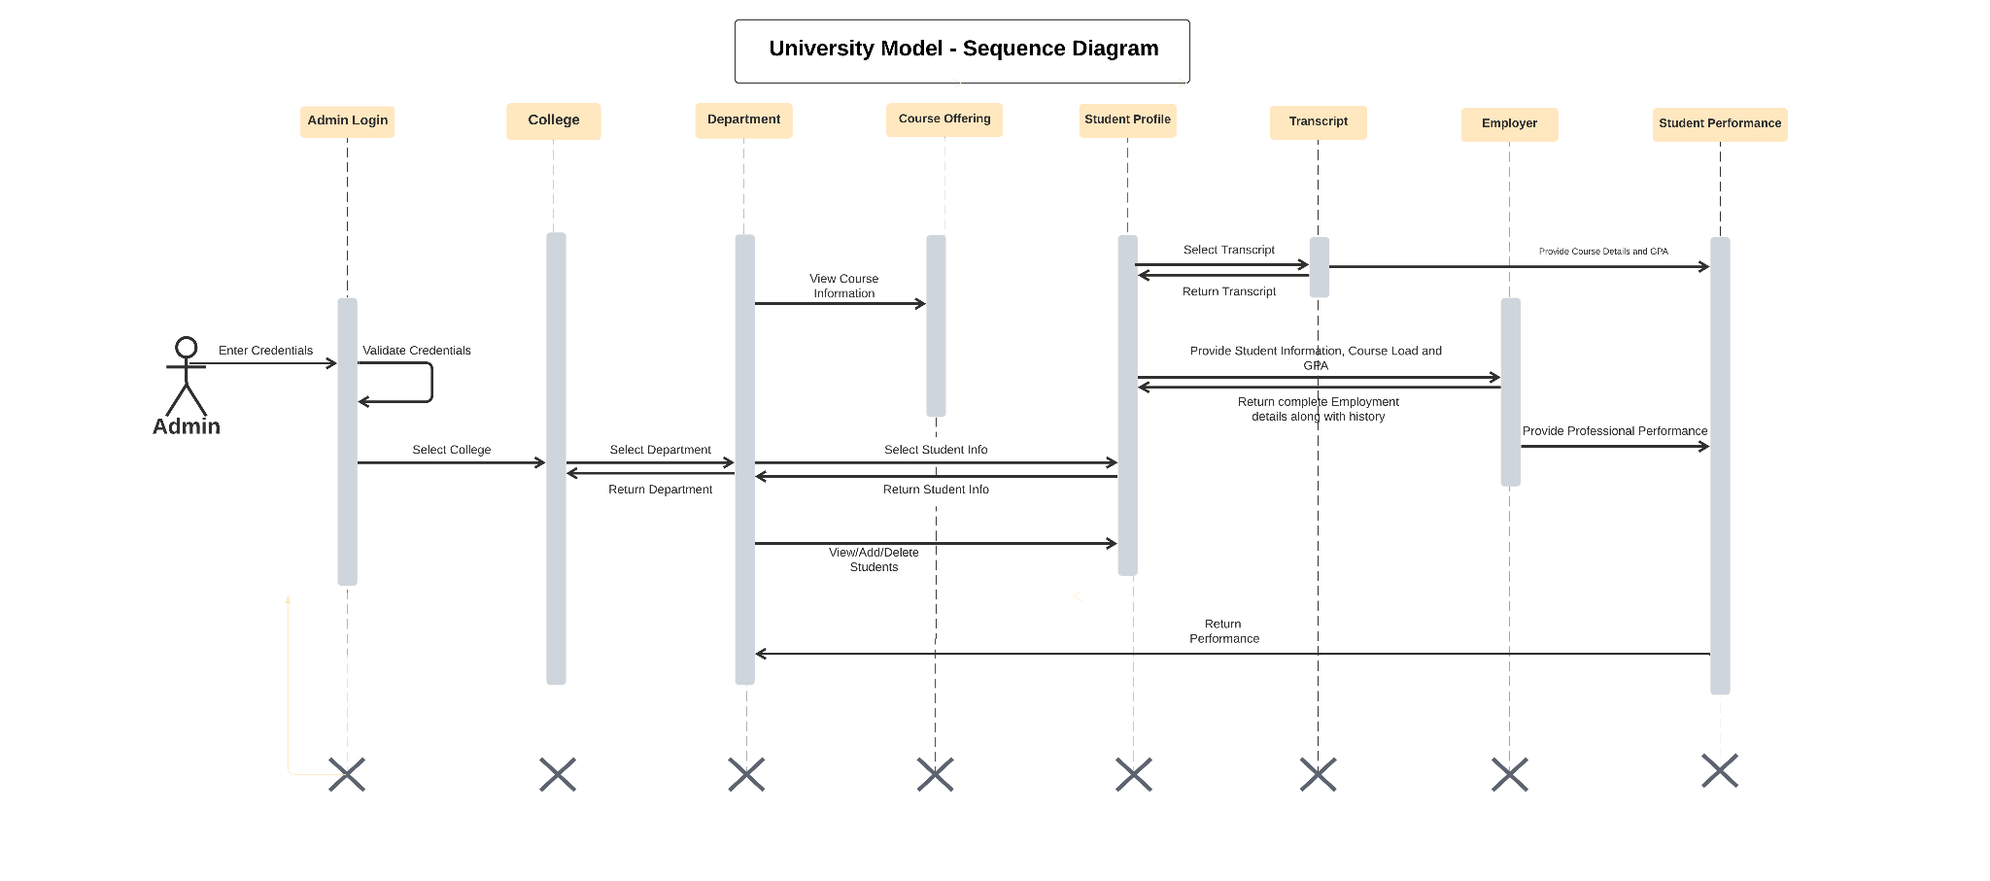

Sample UI:

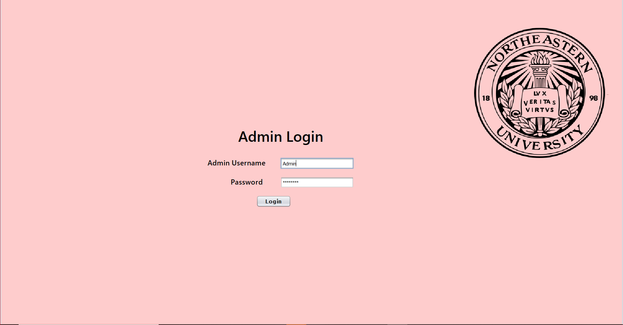

The Admin Login Page is the GateKeeping for the DashBoard to follow.

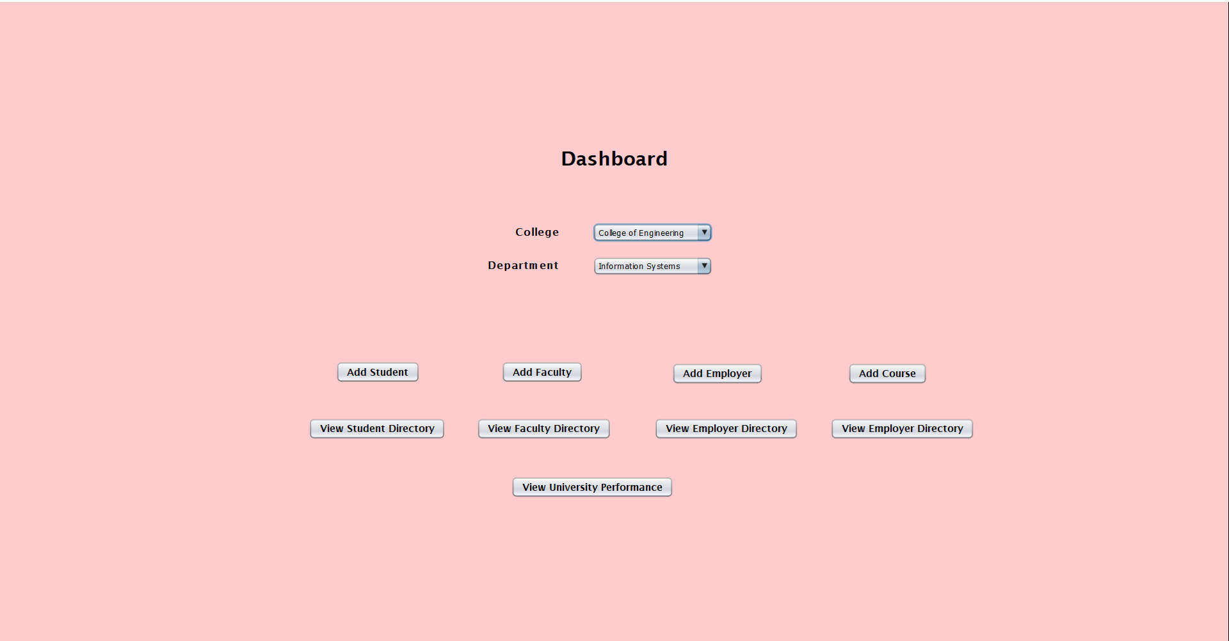

The DashBoard Enables multiple Features across different pages.

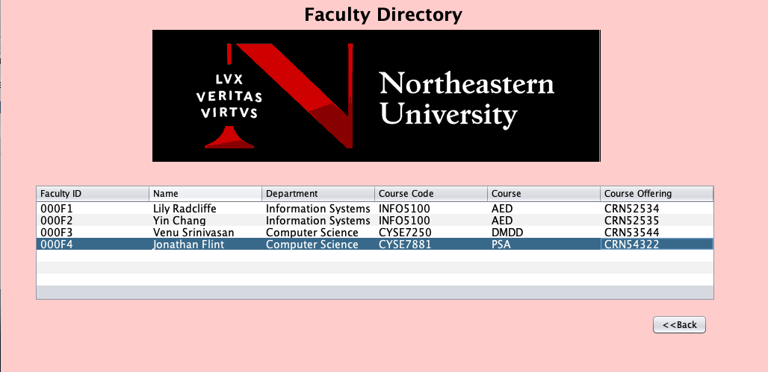

The Faculty Directory is responsible for storing Faculty Information for the University.

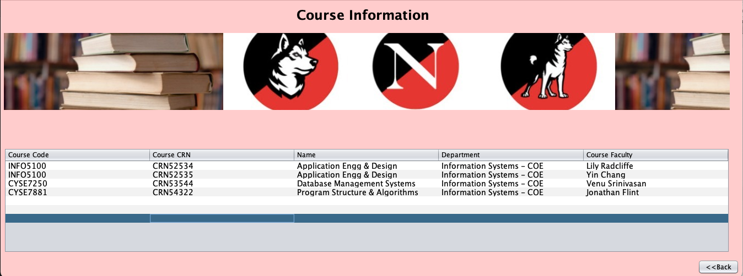

The Course Catalog Maintains an extensive list of all the courses available.

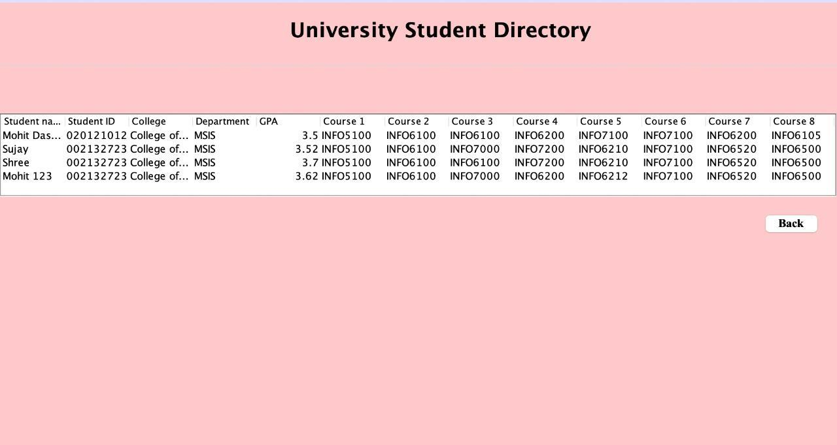

The University Student Directory is responsible for keeping track of Students enrolled in the University, along with other necessary information.

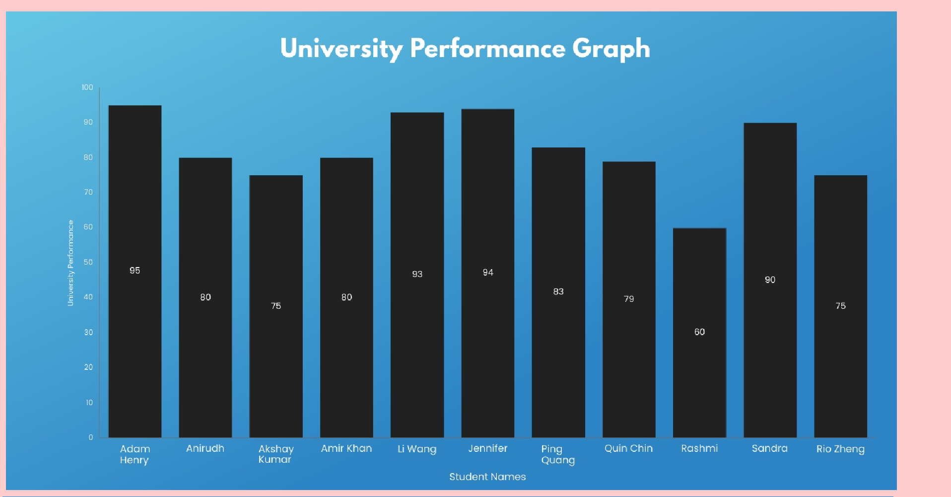

University Performance Graph calculates the aggregates for three parameters mentioned and gives a pictorial view of how impactful it was for student’s Professional performance.